Lab Report No 5
Analysis of Amplitude Modulated and Demodulated Signal using Matlab


Digital Signal Processing Lab
Submitted By: Naveed Ahmad
Registration No: 22PWCSE2165
Section: B

“On my honor , as student of University of Engineering and Technology, I have neither given nor received unauthorized assistance on this academic work”

Student Signature: ____________
Dec. 24, 2024

Department of Computer Systems Engineering
University of Engineering and Technology Peshawar

Provide .m file with detailed comments Tasks:
- Define Amplitude Modulation:
If we vary amplitude of a carrier signal in accordance with the instantaneous value of modulating signal, the process is said to be amplitude modulation.
- Define Amplitude Demodulation:
The process of extracting the original message signal from the modulated carrier signal.
- List three reasons, why we implement Amplitude Modulation in Communication
Systems
  - Amplitude modulation allows multiple signals to be transmitted in the same frequency band using different carrier frequencies.
  - Amplitude modulation is mostly used for transmitting audio signals because the variation in the amplitude of the carrier signal can effectively transmit the sound.
  - Amplitude modulation allows multiple signals to be sent over different carrier frequencies within the same frequency range.

- Define Modulation Index
The measure of how much the carrier signal’s amplitude is varied by the message signal.
μ = mp/A
( where mp is the maximum peak of modulated signal and A is amplitude of carrier signal. ) • μ = 0: There is no modulation, and the carrier signal is unchanged (no message signal is transmitted).
- 0 < μ < 1: The carrier amplitude is varied moderately by the message signal. This is the normal range for most AM transmissions and produces a clear, undistorted signal.
- μ = 1: The carrier amplitude is fully modulated by the message signal, meaning the amplitude variation is equal to the carrier amplitude. This is called 100% modulation.
- μ > 1: This leads to overmodulation, where the carrier's amplitude goes below zero, causing distortion and interference.

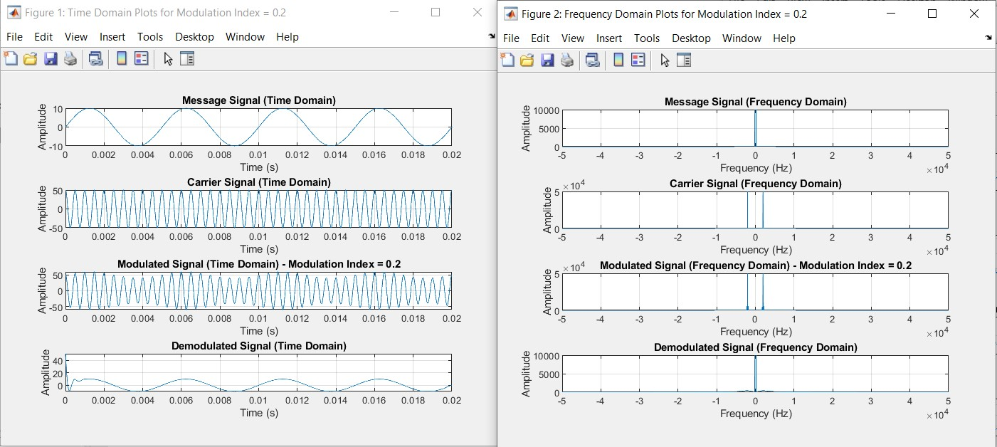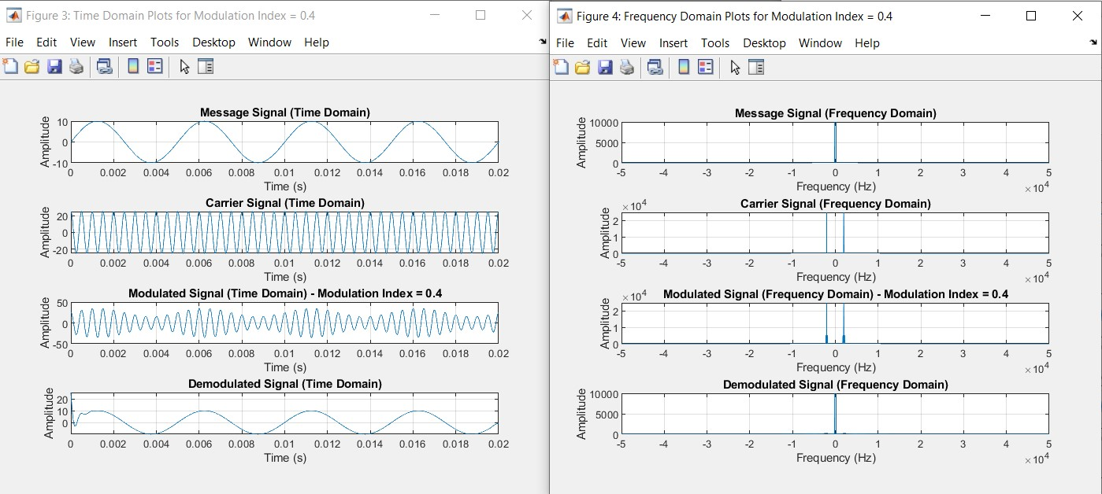
5.

Input Modulation Index from 0 to 1.4, the increment step should be 0.2.
Observe/analyze and comment about the output obse
rved.

•

0.2:

•

0.4:

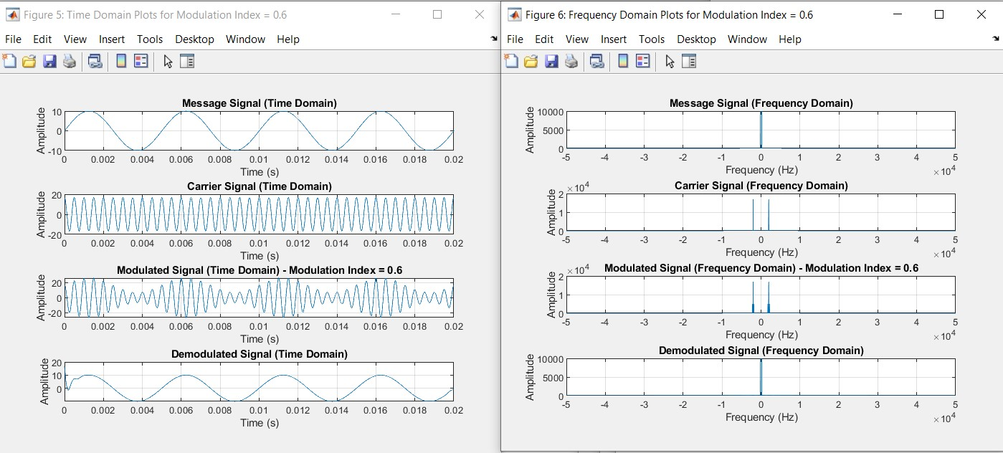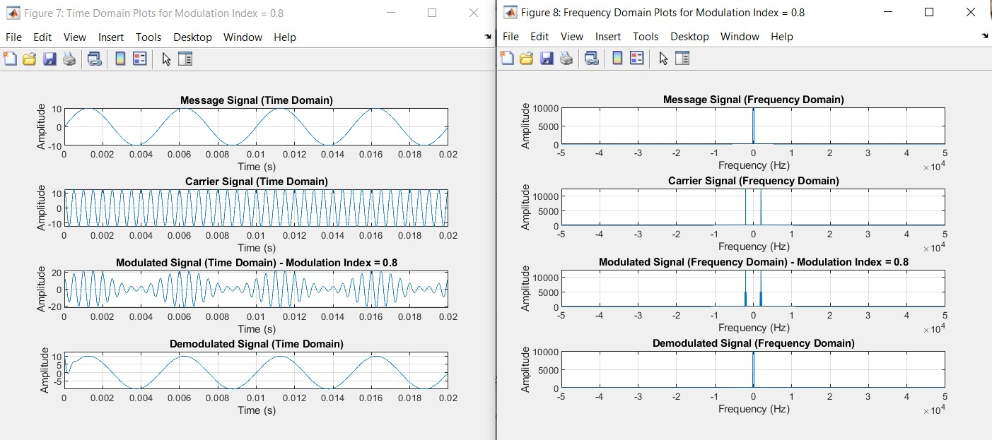
0.6:

•

0.8:

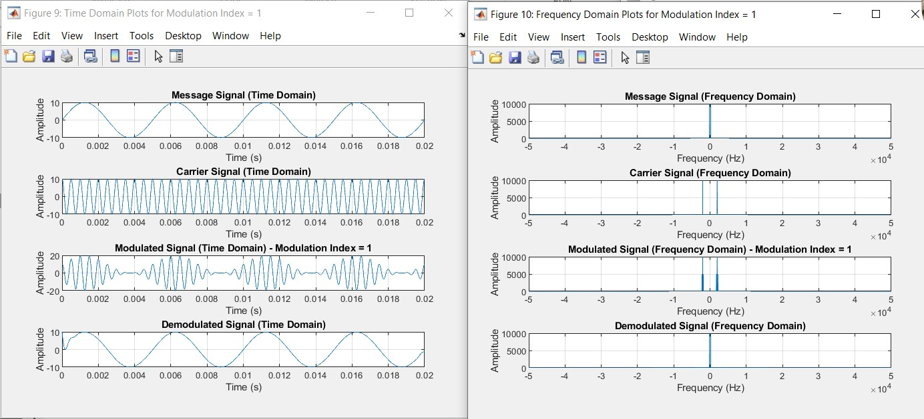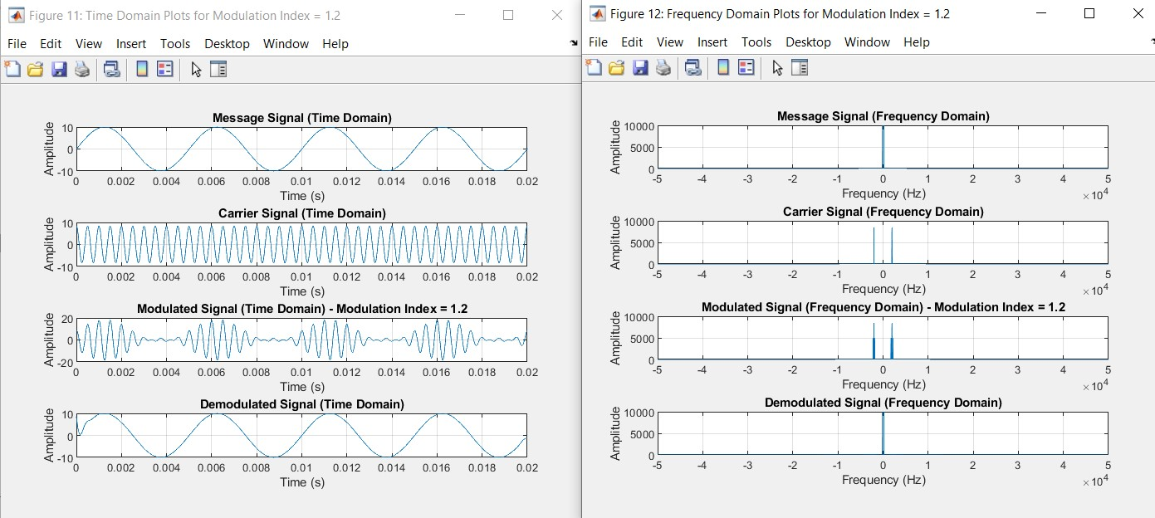
1:

•

1.2:

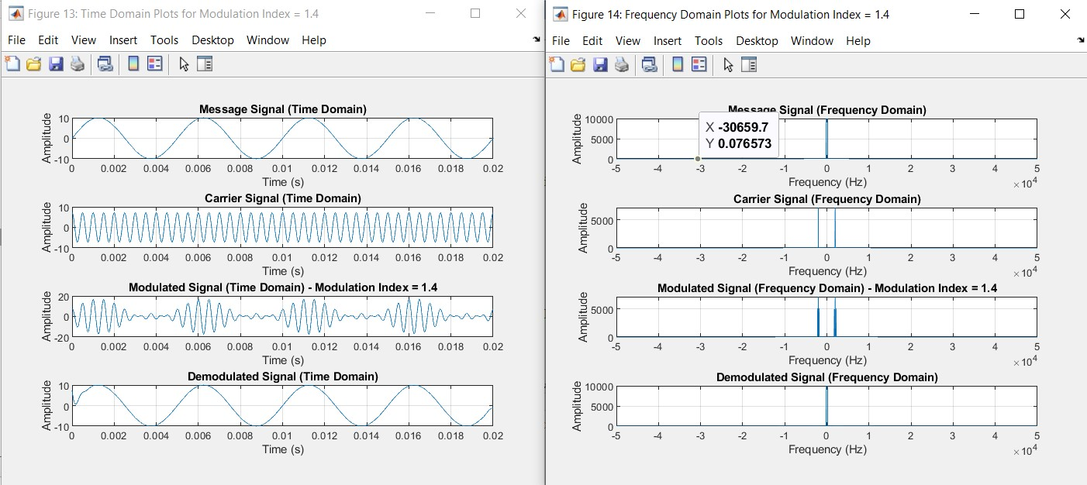
1.4:

Procedure:

1.

Create and plot (both time and frequency domain) a message signal with amplitude 10 and frequency
200
Hz

2.

Create and plot (both time and frequency domain) a Carrier signal with
amplitude 10/Modulation Index
and frequency 2000 Hz

3.

Modulate the message signal with the carrier using the desired Modulation Index. Plot modulated signal
in both time and frequency domain. Observe/Analyze the output.

Hint:
y = ammod(ym, fc, 100000, 0,
Ac);

4.

Demodulate the Modulated signal . Observe/Analyze the output.

Hint:
z = amdemod(y, fc, 100000, 0, Ac);

5.

Following are the plots of the desired outputs

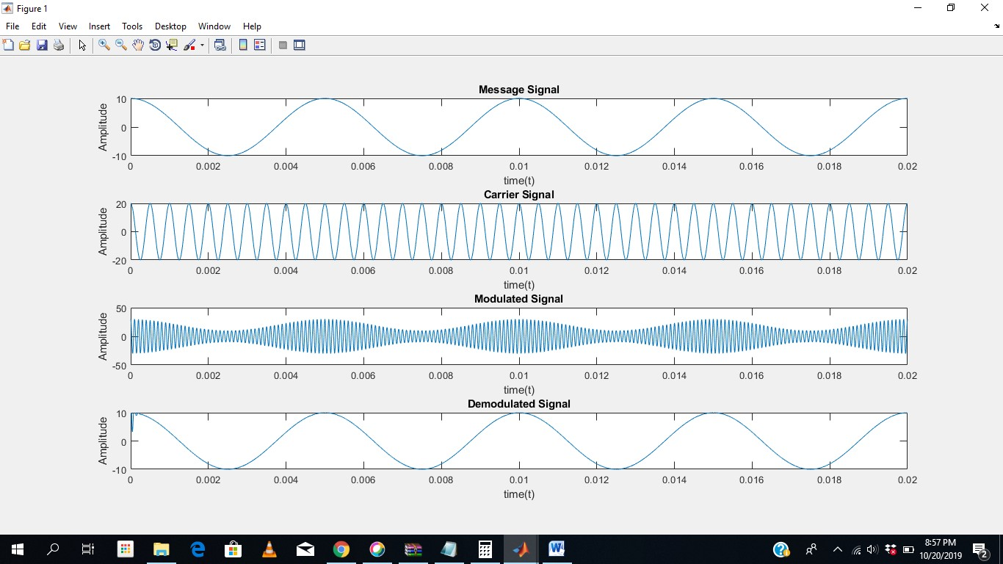
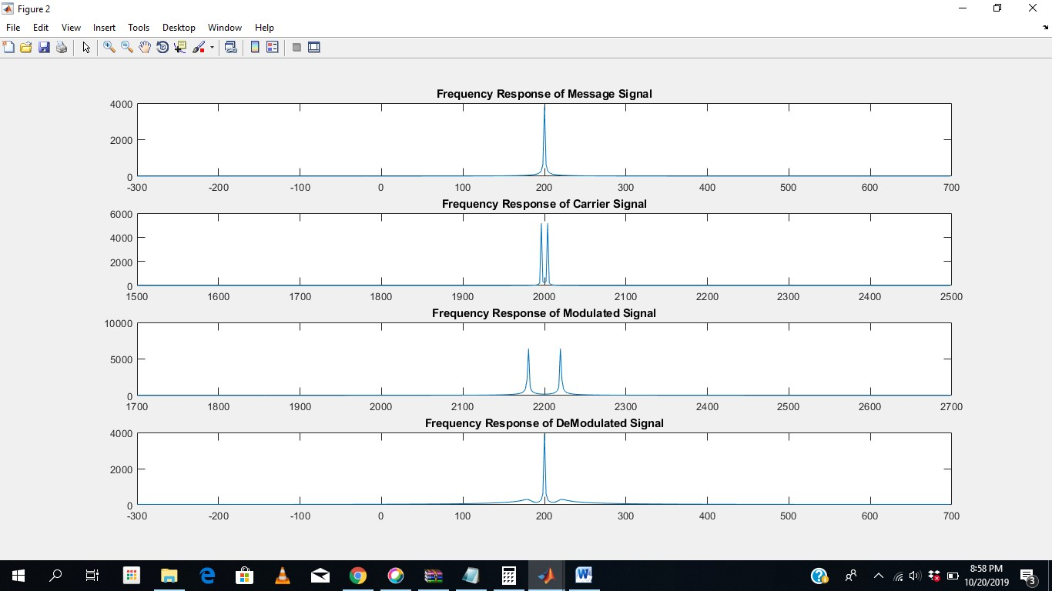

Code:
Fs = 100000; % Sampling frequency (Hz) t = 0:1/Fs:0.02; % Time vector (20 ms duration) Am = 10; % Message signal amplitude fm = 200; % Message signal frequency (Hz) fc = 2000; % Carrier signal frequency (Hz) mu = 0.8; % Modulation index (0 to 1)

message_signal = Am * sin(2 * pi * fm * t);

Ac = Am / mu; % Carrier amplitude (depends on modulation index) carrier_signal = Ac * cos(2 * pi * fc * t);

modulated_signal = ammod(message_signal, fc, Fs, 0, Ac);

demodulated_signal = amdemod(modulated_signal, fc, Fs, 0, Ac);

L = length(message_signal); freq = (-L/2:L/2-1) * (Fs / L);
message_fft = abs(fftshift(fft(message_signal))); carrier_fft = abs(fftshift(fft(carrier_signal))); modulated_fft = abs(fftshift(fft(modulated_signal))); demodulated_fft = abs(fftshift(fft(demodulated_signal)));

% Plot all signals (Time Domain) in one figure figure; subplot(4, 1, 1); plot(t, message_signal); title('Message Signal (Time Domain)'); xlabel('Time (s)'); ylabel('Amplitude'); grid on; subplot(4, 1, 2); plot(t, carrier_signal); title('Carrier Signal (Time Domain)'); xlabel('Time (s)'); ylabel('Amplitude'); grid on; subplot(4, 1, 3); plot(t, modulated_signal); title('Modulated Signal (Time Domain)'); xlabel('Time (s)'); ylabel('Amplitude'); grid on; subplot(4, 1, 4); plot(t, demodulated_signal); title('Demodulated Signal (Time Domain)'); xlabel('Time (s)'); ylabel('Amplitude'); grid on;

% Plot all signals (Frequency Domain) in another figure figure; subplot(4, 1, 1); plot(freq, message_fft); title('Message Signal (Frequency Domain)'); xlabel('Frequency (Hz)'); ylabel('Amplitude'); grid on; subplot(4, 1, 2); plot(freq, carrier_fft); title('Carrier Signal (Frequency Domain)'); xlabel('Frequency (Hz)'); ylabel('Amplitude'); grid on; subplot(4, 1, 3); plot(freq, modulated_fft); title('Modulated Signal (Frequency Domain)'); xlabel('Frequency (Hz)'); ylabel('Amplitude'); grid on; subplot(4, 1, 4); plot(freq, demodulated_fft); title('Demodulated Signal (Frequency Domain)'); xlabel('Frequency (Hz)'); ylabel('Amplitude'); grid on;

OUTPUT:
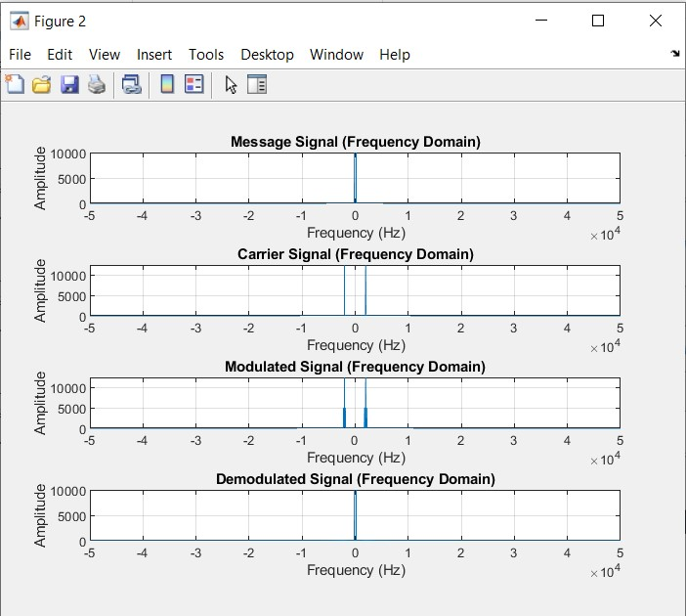
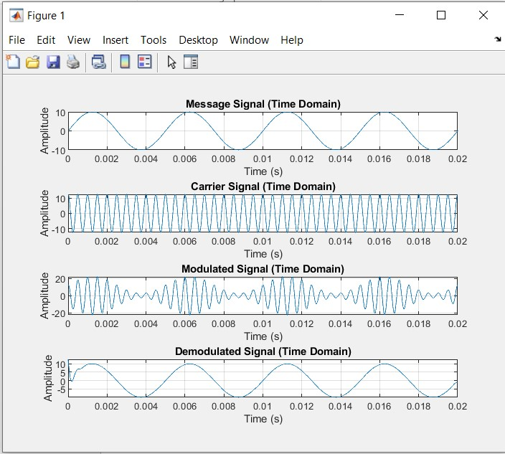

• | ASK:
• | FSK:
• | PSK:
• | QPSK:
• | QAM:

